**Cardiac and metabolic analysis of low-temperature tolerance in two geographic genotypes of *Haliotis diversicolor* and the hybrid.**

**Shuang Liang1,2, Weiwei You2,3,*, Xuan Luo2,3, Jinwei Ke2,3, Miaoqin Huang2,3, Yongjun Guo1, Caihuan Ke2,3,\***

1Tianjin Key Laboratory of Aqua-ecology and Aquaculture, College of Fisheries, Tianjin Agricultural University, Tianjin 300384, China;

2State Key Laboratory of Marine Environmental Science, College of Ocean and Earth Sciences, Xiamen University, Xiamen 361102, China;

3Fujian Key Laboratory of Genetics and Breeding of Marine Organisms, Xiamen University, Xiamen 361102, China.

**\*Corresponding Author:** Caihuan Ke & Weiwei You.

Email: [chke@xmu.edu.cn](mailto:chke@xmu.edu.cn) & [wwyou@xmu.edu.cn](mailto:wwyou@xmu.edu.cn)

**Abstract**

Evident survival heterosis exists in the hybrid (HdDY) of two *Haliotis diversicolor* geographic genotypes (HdTW and HdJP). To explore the physiological basis underlying the hybrid’s heterosis, we compared the survival rate, cardiac performance, oxygen consumption rate, and ammonia excretion rate of the three *H. diversicolor* genotypes at the low temperature. After one year of cultivation, the survival rates of HdTW, HdJP, and HdDY were 27.76%, 86.90%, and 88.57%, respectively. The 50% lethal low temperature (LLT50) of HdTW was higher than HdJP and HdDY. During low-temperature exposure, the abalone’s heartbeat variation pattern appeared as three stages: the heartbeat decreasing stage, arrhythmia stage, and cardiac recovery stage. Four cardiac indices were developed to compare the three genotypes’ cardiac differences: the low-temperature heartbeat decreasing rate (LDR), cardiac arrhythmia temperature (CAT), low-temperature heartbeat recovering rate (LRR), and cardiac recovery time (CRT). HdTW had lower LDR and higher CAT than HdJP and HdDY, while HdJP had lower LRR and higher CRT than HdTW and HdDY, suggesting the hybrid’s cardiac function may inherit the paternal tolerance and maternal recovery characteristics. Meanwhile, the heart rates of HdJP and HdDY were always higher than HdTW at both normal temperature (20 °C) and low temperature (12 °C). The oxygen consumption rate and ammonia excretion rate of HdJP and HdDY were also higher than HdTW after low-temperature exposure. The results indicate the hybrid’s advantageous respiratory and metabolic functions at low temperature, which could be a vital physiological mechanism of the hybrid’s survival heterosis. This study elucidates the cardiac and metabolic differences among different abalone genotypes at the low temperature, which may help us understand the physiological basis of mollusks’ low-temperature tolerance. The evaluation protocol and indices developed in this study could be helpful in mollusks’ physiological researches, such as the low-temperature tolerance heterosis, low-temperature adaption, and habitat differentiation.

Key words: *Haliotis diversicolor*; heterosis; low temperature; cardiac performance; metabolism.

**1. Introduction**

Temperature is an important environmental factor influencing mollusks’ physiological status (Saucedo et al., 2004), as most mollusks’ body temperature is the same as the environmental temperature (Ansart et al., 2003). Low-temperature stress significantly influences mollusks’ physiologies, including growth, survival, ingestion, metabolism, and resistance (Noyola et al., 2013; Saucedo et al., 2004; Strand et al., 2011; Takami et al., 2008). Therefore, low-temperature tolerance is considered to be an important economic trait of aquaculture species (Nie et al., 2016).

The hybrids often show advantageous traits towards their parents, known as the heterosis phenomenon, which exists in many mollusk species (Guo, 2009). Some mollusks’ hybrids also show advantages in the low-temperature tolerance. For example, the two apple snails *Pomacea canaliculata* (low temperature tolerant) and *P. maculata* (low temperature-sensitive) and their F1 hybrids and backcross F2 hybrids, were exposed to 0 °C for five days, and their survival rates were recorded. Both the F1 and F2 hybrids had higher survival rates than *P. maculate*, showing mid-parent heterosis (Matsukura et al., 2016). The hybrid of *Haliotis kamtschatkana* and *H. discus hannai* Ino showed a superior growth rate than the parental genotypes at 8 °C or 18 °C (Hoshikawa et al., 1998). In our previous study, the two *Haliotis diversicolor* geographic genotypes, Taiwan genotype (low temperature-sensitive, named HdTW) and Japan genotype (low temperature tolerant, named HdJP), were hybridized. The survival rate of the F1 hybrid (HdTW ♀ × HdJP ♂, named as HdDY) was higher than that of HdTW and slightly higher than that of HdJP in the winter months (You et al., 2009). The HdDY has been widely cultured in China’s southern provinces due to its survival heterosis (You et al., 2015). However, the physiological mechanisms underlying the abalone’s heterosis remain unknown.

To assess the mollusk’s low-temperature tolerance, researchers usually measure the organism’s lethal lower temperature (LLT) or median lethal low temperature (LLT50), which respectively represents the temperature at which 100 % or 50 % of the animals were dead. (Ansart et al., 2003). The LLT and LLT50 have been used as low-temperature tolerance indicators in various mollusks, such as limpet (Chiba et al., 2016), octopus (Zhou et al., 2010), oyster (Strand et al., 2011), and snail (Zhou et al., 2010). The two indicators are also used to evaluate the tolerance differences between a mollusk species’ different genotypes. (Guo et al., 2019; Matsukura et al., 2016; Pernet et al., 2007). However, based merely on the LLT and LLT50, researchers are hard to have a detailed insight into the mollusks’ physiological performances facing low-temperature stress.

The heart rate could be used as a sensitive and accurate parameter reflecting the organism’s respiratory reaction to hazard temperature stresses. Researchers have started to use infrared detection methods to monitor the crustaceans and shellfish’ heartbeats since 1999 (Handy et al., 1999). By continuously measuring the mollusk’s heart rate and recording the environmental temperature, researchers could establish an Arrhenius curve linking the heart rate and the temperature. The Arrhenius break temperature (ABT), the temperature at which the mollusk’s heart rate decreases dramatically with progressive heating, could be used to indicate the organisms’ thermal tolerance limit. The ABT has been successfully determined in various mollusk species, such as the abalone, sea snail, limpet, and mussel (Braby et al., 2006; Chen et al., 2016; Dong et al., 2011). The heart rate could also be used to assess the mollusk’s cardiac performance under low-temperature stress. For example, the two bivalve species *Mytilus edulis* and *Modiolus modiolus* had the lowest heart rates in the winter months (Bakhmet et al., 2019). The juvenile oysters’ average heart rate was 83.2 beats/min at 22 °C. As the temperature cooled from 22 °C to 10 °C, the average heart rate of the oysters decreased at a rate of 7.3 beats·min-1 degree-1. (Domnik et al., 2016). The mussels *Mytilus genus* and *M. edulis* also showed heart rate decreasing during low-temperature exposure (Braby et al., 2006; Widdows, 1973). The abalone’s low-temperature heart rate variation pattern has not been studied yet. Hence, it is necessary to establish abalone’s cardiac performance under low-temperature stress, which could help us understand the abalone’s cardiac response to low-temperature stress; meanwhile, enable the comparison between different abalone genotypes’ low-temperature resistance.

In this study, we analyzed and compared the cardiac performance of the three *H. diversicolor* genotypes, HdTW, HdJP, and HdDY, during low-temperature exposure. The one-year cultivation survival rate, LLT50, oxygen consumption rate, and ammonia excretion rate were also tested in the three genotypes. We wish to establish the procedure of detecting and analyzing abalone’s cardiac performance under low-temperature stress and dissect the physiological mechanisms of the hybrid abalone’s low-temperature resistance heterosis.

2. Materials and methods

2.1. Abalones

The three *H. diversicolor* genotypes: Taiwan genotype (HdTW), Japan genotype (HdJP), and hybrid genotype (HdDY), were used in this study. Before the experiments, the abalones from the three genotypes were labeled and mixed cultured under the same condition (reared in running seawater; fed with fresh alga *Gracilaria confervoides*; salinity 33 ‰; pH 8.0) in the Fuda abalone farm (Jinjiang, China). The shell length of HdTW, HdJP, and HdDY was 49.89 ± 3.36 cm, 46.45 ± 3.74 cm, and 48.73 ± 2.89 cm, separately.

2.2. Survival rate determination

From January 2016 to December 2016, the survival rates of 450 abalones from each *H. diversicolor* genotype (1,350 abalones in total) were observed. The abalones were labeled and mix cultured in nine abalone culture cages (each cage contained 50 abalones from each genotype, 150 abalones in total). The cages were separately placed in three culture ponds (each pond contained three cages, the pond size: width × length × water height = 3.0 × 4.0 × 1.5 m). The ponds were filled with running sand-filtered seawater and aerated continually. The abalones were fed with fresh alga *Gracilaria confervoides* once a day. The water temperature was recorded at a 10-minute interval by the onset temperature logger (UA-002, HOBO, America). The amounts of living abalones from each genotype were examined on the 15th of each month. Then the cumulative survival rates of the three genotypes were calculated.

2.3. Abalones acclimation

For each genotype, 300 abalones with a regular appearance and good vitality were used for the laboratory experiments (900 abalones in total). The abalones were acclimated under the controlled laboratory conditions (reared in still seawater with aeration, the seawater was replaced every day; fed with fresh alga Gracilaria confervoides; temperature 20 ± 1 °C; salinity 33‰; pH 8.0) for 14 days. No abalone was dead during the acclimation.

2.4. Heart rate determination protocol

A non-invasive method was established to measure abalone’s heart rate according to the protocol described before (Chelazzi et al., 1999; Dong et al., 2011) with some modifications. As is shown in Figure 1, the test abalone was reared in a glass baker (10 L volume) filled with aerated seawater. Then the baker was immersed with a water bath in a larger incubator (100 L volume). The water temperature was controlled using the thermostatic water bath (TH-5045D, Tianheng, China) and recorded using the thermometer (Fluke 45 Ⅱ, Fluke, America). The abalone’s heart rate signal was captured and amplified by the signal amplifier (AMP03, Newshift, Portugal), then filtered and recorded by the data acquisition hardware (Powerlab, ADInstruments, America). The final data were visualized as heartbeat waveforms in the LabChart software (LabChart 7.0, ADInstruments, America), then the heartbeat recognition and heart rate counting were processed using the software.

2.5. Low-temperature treatment

To investigate the abalone’s cardiac performance during low-temperature exposure, we decreased the water temperature from 20 °C to 8 °C at a rate of 2.3 °C/hour, then recovered the temperature to 20 °C at a natural warming rate. The real-time heart rate of the test abalone was recorded throughout the whole protocol.

To compare the three *H. diversicolor* genotypes’ cardiac differences, we tested the heartbeat variations of 24 abalones from each genotype (72 abalones in total) following the above protocol. The low-temperature heartbeat decreasing rate (LDR), cardiac arrhythmia temperature (CAT, °C), low-temperature heartbeat recovery rate (LRR), and cardiac recovery time (CRT, min) were assessed in the three genotypes (details of the four parameters are explained in “3.2 Cardiac performance of *H. diversicolor* during low-temperature exposure”). Besides, the three genotypes’ heart rates at 20 °C and 12 °C were assessed by the LabChart software.

2.6. LLT50 determination

The LLT50 of HdTW, HdJP, and HdDY were determined following the protocol described before (Ansart et al., 2003) with some modifications. The abalones were exposed to six temperature gradients (1°C, 3°C, 5°C, 7°C, 9°C, and 11°C). For each temperature gradient experiment, 30 abalones from each genotype (90 abalones in total) were equally placed into three replicate containers (the glass bakers shown in Figure 1, each baker contained 10 abalones from each genotype, 30 abalones in total). The water temperature was then decreased from 20 °C to 1°C, 3°C, 5°C, 7°C, 9°C, or 11°C at a rate of 2.3 °C/hour. The abalones reared consistently at 20 °C were regarded as the control group. The temperature was maintained at the designated gradient for 12 h or 24 h, then recovered to 20 °C at a natural warming rate. After 24 h recovery at 20 °C, the abalones who lost foot attachment were regarded as dead. The mortalities of the three genotypes were recorded, then the LLT50 was calculated by Probit analysis.

2.7. Oxygen consumption and ammonia excretion rates determination

The oxygen consumption rate (OC) and ammonia excretion rate (AE) of HdTW, HdJP, and HdDY during low-temperature exposure were determined. Thirty abalones from each genotype (90 abalones in total) were equally placed into three replicate containers (the glass bakers shown in Figure 1, each baker contained ten abalones from each genotype, 30 abalones in total). The abalones were reared at 12 °C (low-temperature group) or 20 °C (control group) for 168 h. The OC and AE of six abalones from each genotype (18 abalones in total) were tested at 0 h, 6 h, and 168 h of the experiment.

The abalone’s OC was measured according to the previous study (Shen et al., 2020) with some modifications. Two abalones from the same genotype were put into a 2L respiration chamber. The chamber was filled with sterilized seawater and sealed with a plastic membrane to prevent gas exchange with air. Then the chamber was placed into a temperature-control incubator (BPS-500CL, Yiheng, China). The seawater temperature in the chamber was kept the same as the abalone’s rearing temperature (12 °C or 20 °C) during the measurement. The dissolved oxygen concentration (DO, mg/L) in the seawater was measured by a polarographic oxygen electrode (YSI-550A, HACH, America) at 0 min and 60 min of the experiment. Chambers with no abalone inside were used as control. The OC (ug·g-1·h-1) of the abalone was calculated according to the equation:

$$OC=\frac{{\left({DO}_{0 min}-{DO}_{60 min}\right)}_{treat}-{\left({DO}_{0 min}-{DO}_{60 min}\right)}_{control}}{WW}×V_{water}×1000$$

DO0 min and DO60 min mean the DO in the seawater at 0 min and 60 min separately; the subscript “treat” means chambers with live abalones; the subscript “control” means chambers with no abalone; WW is the wet weight of the test abalones; Vwater is the volume of seawater.

The abalone’s AE was measured together with the OC’s measurement described below. At 0 min and 60 min of the measurement, water samples were collected from the respiration chambers. The ammonia concentration (AC, mg/L) of the water sample was determined with a spectrophotometer according to the phenol-hypochlorite method (Zhang et al., 2019). The AE (ug·g-1·h-1) of the abalone was calculated according to the equation:

$$AE=\frac{{\left({AC}_{60 min}-{AC}_{0 min}\right)}_{treat}-{\left({AC}_{60 min}-{AC}_{0 min}\right)}_{control}}{WW}×V_{water}×1000$$

AC0 min and AC60 min mean the AC in the seawater at 0 min and 60 min separately; the subscript “treat” means chambers with live abalones; the subscript “control” means chambers with no abalone; WW is the wet weight of the test abalones; V water is the volume of seawater.

2.8. Statistical analysis

All data were analyzed using SPSS 16.0 (IBM, America). One-way analysis of variance and posthoc multiple comparisons were conducted to compare the differences in the survival rate, heart rate, LLT50, OC, and AE among the different abalone genotypes. Differences were considered significant at p < 0.05. The results were expressed as mean ± SD.

3. Results

3.1. Cumulative survival rates of the three *H. diversicolor* genotypes

The cumulative survival rates of HdTW, HdJP, and HdDY from January 2016 to December 2016 are shown in Table 1. The three genotypes’ survival rates all continuously decreased, while the HdTW’s survival rate decreased more rapidly than HdJP and HdDY. By the end of this experiment (December 2016), the survival rates of HdJP and HdDY were significantly higher than that of HdTW. Besides, the decrease in HdTW’s survival rate was especially notable in February 2016, when the average monthly seawater temperature (14.29 °C) was the lowest in the whole year. These results suggest that HdDY has superior survival ability compared to the maternal genotype, especially at low temperatures.

3.2. Cardiac performance of *H. diversicolor* during low-temperature exposure

Figure 2 shows the heart rate variation pattern of *H. diversicolor* during low-temperature exposure, while Figure 3 shows the cardiograms of *H. diversicolor* at 20 ℃ and 12 ℃. As the temperature decreased from 20 °C to 8 °C and then recovered to 20 °C, the abalone’s heart rate changing pattern could be divided into the following three stages.

(1) Linear decreasing stage

At this stage, the abalone’s heart rate decreased linearly as the temperature went down. To quantitatively analyze the abalone heart rate’s decreasing rate, we established the linear regression equation between the exposure time and the abalone’s heart rate, then defined the equation’s slope as the low-temperature heartbeat decreasing rate (LDR). Besides, the abalone’s heartbeat waveform was regularly repeated at this stage, as shown in Figure 3a.

(2) Arrhythmia stage

As the temperature went down to a certain degree, the abalone’s heartbeat waveform started to show abnormalities, presented as the unregular heartbeat waveform, occasionally happened asystole, and decreased heartbeat frequency (Figure 3b). Meanwhile, as the waveform became unregular and fluctuating, the error rate of heartbeat recognition and counting (by the LabChart software) would go up, resulting in heart rate data chaos (Figure 2). We defined the temperature at which arrhythmia started to happen in abalone’s heartbeat as the cardiac arrhythmia temperature (CAT) to evaluate the abalone’s cardiac endurance limit of low-temperature stress.

(3) Recovery stage

As the temperature recovered to 20 °C, the abalone’s heartbeat waveform returned to the standard shape (Figure 3a), and the abalone’s heart rate gradually recovered to the initial level (Figure 2). The phenomenon suggests the recovery of the abalone’s heartbeat. To quantitatively analyze the abalone’s heart rate recovery rate, we established the linear regression equation between the exposure time and the abalone’s heart rate and defined the equation’s slope as the low-temperature heartbeat recovery rate (LRR). Besides, we defined the time length that the abalone needed for heartbeat recovery (since the temperature starts to rise) as the cardiac recovery time (CRT).

3.3. Heart rate variation patterns ofthe three *H. diversicolor* genotypes during low-temperature exposure

The heart rates of the three *H. diversicolor* genotypes at 20 °C and 12 °C are shown in Figure 4. At the normal temperature (20 °C), the heart rates of HdJP and HdDY were 43.30 beats/min and 43.84 beats/min, respectively, both significantly higher than that of HdTW (39.06 beats/min). At the low temperature (12 °C), the heart rate of HdJP (20.79 beats/min) and HdDY (21.67 beats/min) was also higher than that of HdTW (15.55 beats/min). Besides, HdTW has a larger individual difference in heart rate than the other two genotypes. These results suggest HdJP and HdDY have the better cardiac performance at both normal temperature and low temperature.

The LRR, CAT, LDR, and CRT of the three genotypes are shown in Figure 5. At the heartbeat decreasing stage, HdTW was lower in LDR and higher in CAT compared to HdJP and HdTW (Figure 5a-b). The results suggest that HdTW had a faster heartbeat decreasing rate during the low-temperature exposure and encountered arrhythmia at a higher temperature compared to HdJP and HdTW. At the heartbeat recovery stage, HdJP was lower in LRR and higher in CRT compared to HdTW and HdDY (Figure 5c-d), suggesting HdTW and HdDY were superior in the heartbeat recovery. The above results indicate HdDY’s cardiac function has paternal tolerance and maternal recovery characteristics under low-temperature stress.

The individual difference in LDR, CAT, LRR, and CAT was most apparent in HdTW, HdJP, HdTW, and HdJP, respectively, suggesting that the hybrid genotype has smaller individual difference in cardiac performance under low-temperature stress compared to its parents.

3.4. LLT50 of the three *H. diversicolor* genotypes

No abalone was dead in the 12 h and 24 h control groups (20 °C). Figure 6a shows the three *H. diversicolor* genotypes’ survival rates after 12 h exposure to different temperatures. No abalone was dead in the 11 °C and 9 °C groups, while a slight decrease in HdTW and HdJP’s survival rates was observed in the 7 °C group. In the 5 °C and 3 °C groups, obvious death happened in all three genotypes, while the survival rates of HdTW were significantly lower than that of HdJP and HdDY. No abalone survived in the 1 °C group.

Figure 6b shows the survival rates of the three genotypes after 24 h exposure to different temperatures. HdJP and HdDY had 100% survival rates, while HdTW’s survival rate was 94.33% in the 11 °C group. HdTW’s survival rate was significantly lower than HdDY in the 9 °C group and significantly lower than HdJP and HdDY in the 5 °C and 3 °C groups. No abalone survived in the 3 °C and 1 °C groups.

The 12 h-LLT50 and 24 h-LLT50 of HdJP and HdDY were significantly lower than HdTW, as shown in Table 2. These results indicate that HdDY was like the paternal genotype in resistance to short-term low-temperature exposure, which might be an essential mechanism of the HdDY’s survival heterosis (Table 1) beyond the maternal genotype.

3.5. OC and AE of the three genotypes during low-temperature exposure

Figure 7 shows the OC and AE of the three *H. diversicolor* genotypes reared at 12 °C and 20 °C. During the 168 h exposure, the three genotypes’ OC and AE kept stable at 20°C and decreased continuously at 12 °C.

At 0 h and 6 h of the exposure, no significant differences were identified between the OC of the three genotypes reared at 12 °C or 20 °C. At 168 h of the exposure, the OC of HdTW was significantly lower than HdJP and HdDY at 12 °C (Figure 7a).

At 0 h and 6 h of the exposure, the AE of HdDY was lower than both parents at 12 °C or 20 °C. At 168 h of the exposure, the AE of HdTW was lower than HdJP and HdDY at 12 °C (Figure 7b). The above results imply that HdJP and HdDY are more active in respiration and metabolisms compared to HdTW.

4. Discussion

*Haliotis diversicolor* is a traditional cultured abalone species in China’s southern provinces (Guo, 2009; You et al., 2009). As a warm-adapted species, the *H. diversicolor* (Taiwan genotype)is susceptible to low temperature (Zhang et al., 2004). In recent years, the survival rate of the widely cultivated *H. diversicolor* Taiwan genotype continuously decreases, which leads to significant economic loss (You et al., 2009). An important reason for the abalone’s survival decrease is the abalone’s germplasm degradation brought by frequent inbreeding. To solve this problem, we introduced the *H. diversicolor* Japan genotype into China and hybridized the Japan genotype with the Taiwan genotype. The hybrid genotype is featured by its superior survival in aquaculture than the initially cultured Taiwan genotype (You et al., 2009). At present, the hybrid *H. diversicolor* has been widely cultured in China’s southern provinces. However, despite the significance of the hybrid’s heterosis, we know little about the physiological mechanisms underlying the heterosis phenomenon.

In this study, the parental and hybrid *H. diversicolor* genotypes’ survival rates were compared (Figure 1). The results suggest HdDY inherits the low-temperature resistance ability from HdJP, showing mid-parent heterosis over HdTW. The three genotypes’ differences in low-temperature resistance were also reflected in their LLT50 values (Figure 6). HdDY’s 12h-LLT50 and 24h-LLT50 were 0.54 °C and 0.76 °C lower than the maternal genotype HdTW, respectively. The superior low-temperature resistance is also reported in the hybrid/hybrids of apple snail (Matsukura et al., 2016)*,* periwinkle (Chiba et al., 2016), and other abalone species (Hoshikawa et al., 1998), indicating the mollusks’ low-temperature resistance could be improved through hybridization.

Appropriate physiological indices are essential for exploring the physiological basis of HdDY’s heterosis. Cardiac performance has been widely used to evaluate the mollusks’ physiological status under heat stress (Stillman et al., 1996) (Chen et al., 2016; Dong et al., 2011; Ganser et al., 2013; Williams et al., 2011; Xing et al., 2016; Zhang et al., 2019; Zhang et al., 2014). When a mollusk is exposed to continually rising temperature, its heart rate would rise linearly at first, then sharply decrease at a specific temperature (the Arrhenius breaking temperature, ABT) that exceeds the organism’s tolerance limit. The ABT has been widely used to reflect mollusks’ thermal tolerance limits (Chen et al., 2016). The mollusks’ heart rate variations under low-temperature stress are also investigated in some species, such as the mussels (Bakhmet et al., 2019; Braby et al., 2006), oyster (Domnik et al., 2016), and scallop (Xing et al., 2019). These studies indicate that mollusks would show a decreased heart rate when the temperature goes down. However, useful physiological indices (like the ABT used in mollusks’ thermal resistance evaluation) are still lacking in describing and evaluating mollusks’ cardiac performance under low-temperature stress. This study found the abalone’s heartbeat variation during low-temperature exposure could be divided into three stages: the heartbeat decreasing stage, arrhythmia stage, and cardiac recovery stage (Figure 2-3). This phenomenon also exists in some other mollusks. The juvenile oysters acclimated at 22 °C and 10 °C were exposed to a cooling process (22 °C to 10 °C) followed by a warming process (10 °C to 22 °C). During the exposure, the oysters’ heart rates decreased first then recovered. Besides, during the cooling process, asystole (presented as cardiac arrests) started to appear at 18 °C in the 22°C-acclimated oysters, and at 12°C in the 10°C-acclimated oysters (Domnik et al., 2016). The decreased heart rate and irregular heartbeat waveform were also observed in the scallops exposed to a low temperature (5 °C) (Xing et al., 2019). Hence, the mollusks’ heartbeat variations under low-temperature stress could have some common characteristics. To quantificationally describe these characteristics, we developed the LDR to show the decreasing rate of abalone’s heart rate during cooling processes, CAT to indicate the temperature at which the abalone starts to show arrhythmia, LRR to show the recovering speed of abalone’s heart rate during warming process, and CRT to show the time the abalone needs to recover cardiac functions. These cardiac indices would facilitate the description of abalone’s cardiac performance under low-temperature stress and comparison of different abalone genotypes’ cardiac characteristics.

The cardiac performance of the three *H. diversicolor* genotypes was compared. The HdTW’s heart rate was always lower than HdJP and HdDY, at both normal temperature (20 °C) and low temperature (12 °C) (Figure 4). We may infer that HdJP and HdDY have higher intrinsic rates of cardiac activity, as well as superior cardiac functions at low temperatures, compared to HdTW. Similarly, the cold-adapted mussel *M. trossulus* exhibited a higher heart rate (approximately 1.5 fold) than the warm-adapted species *M. galloprovincialis* at 21 °C, 14 °C, and 0 °C (Braby et al., 2006). The 10 °C-acclimated juvenile oysters had significantly higher heart rates than the 22°C-acclimated oysters (Domnik et al., 2016). Although the effect of low temperature on abalone’s heart rate has not been investigated before, a study comparing the thermal tolerance of *H. discus hannai* (DD), *H. gigantea* (GG), and their hybrid (DG) also identified higher maximum heart rates (heart rate at the ABT point) in the heat-tolerant genotypes GG and DG, other than the heat-sensitive genotype DD (Chen et al., 2016). Hence, the positive relationship between a mollusk’s heart rate and its resistance to adverse temperature could be concluded. Upon temperature stress, a mollusk’s higher heart rate may indicate its stronger respiratory or metabolic functions, which could help the organism deal with the stress. Furthermore, the organism’s heart rate is positively correlated with the organism’s oxygen consumption and ammonia excretion rates in many mollusk species (Bakhmet, 2017; Marshall et al., 1992; Santini et al., 2000). In this study, the HdTW’s OC and AE were lower than the other two genotypes after 168 h exposure to the low temperature (12 °C) (Figure 7). The results indicate at low temperature, the decrease of respiratory and metabolic activities is more evident in HdTW other than HdJP and HdDY.

Besides the heart rate count, we also compared the heart rate variation trends of the three genotypes. HdJP and HdDY had higher LDR and lower CAT than HdTW (Figure 5a-b) under low-temperature stress, which means the hybrid and paternal genotypes could maintain a relatively higher heart rate, and reach the arrhythmia stage more slowly, than the maternal genotype. Similarly, the 22 °C-acclimated oysters also had higher heartbeat decreasing rates (7.3 beats/min) during the cooling process than the 10 °C-acclimated oysters (5.1 beats/min), while asystole happened in the 22°C-acclimated oysters at a higher temperature (18 °C) than the 10°C-acclimated ones (12 °C) (Domnik et al., 2016). Hence, HdJP and HdDY, with more stable heart rates and higher tolerance limits during low-temperature exposure, may perform better in dealing with the physiological stress brought by the adverse temperature. Interestingly, unlike the LDR and CAT, HdTW and HdDY had higher LRR and smaller CRT than HdJP in the recovery stage, indicating the hybrid is maternal-like in heartbeat recovery ability. This tendency is also present in the oysters. The 22°C-acclimated oysters exhibited higher heartbeat recovery speed than the 10 °C-acclimated oysters (Domnik et al., 2016). We could infer that HdTW is more warm-adapted than cold-adapted. When temperature increases to an appropriate level, the HdTW’s suppressed heartbeat would soon be released. HdDY may inherit this characteristic from the maternal genotype, showing a similar heartbeat recovery tendency to HdTW.

In conclusion, we analyzed the heartbeat variation pattern of *H. diversicolor* during low-temperature exposure. Four cardiac indices, including the LDR, CAT, LRR, and CRT, were developed to describe the abalone’s heartbeat decrease and recovery characteristics during the exposure. The survival rates and LLT50 of the three *H. diversicolor* genotypes were compared. The hybrid genotype showed low-temperature survival heterosis beyond the maternal genotype. To elucidate this heterosis phenomenon, we compared the cardiac and metabolic performance of the three *H. diversicolor* genotypes. The results indicate that during low-temperature exposure, the hybrid genotype has a higher heart rate, lower cardiac limit, better heartbeat stability, and higher heartbeat resilience than the maternal genotype. The three genotypes’ cardiac differences also patterned with their OC and AE differences, indicating the hybrid’s advantageous respiratory and metabolic functions at low temperature. This is the first study to elucidate the abalone’s cardiac variation pattern at low temperature, which could help us understand the physiological basis of mollusks’ low-temperature tolerance. We hope the evaluation protocol and indices developed in this study could be helpful in mollusks’ physiological researches, such as low-temperature tolerance heterosis, low-temperature adaption, and habitat differentiation.

Acknowledgment

This work was supported by the National Natural Science Foundation of China (Grant No. 31902369); Earmarked Fund for Modern Agro-industry Technology Research System (Grant No. CARS-49); Tianjin Natural Science Foundation (Grant No. 18JCQNJC84500); Tianjin Seed Industry Science and Technology Major Project (Grant No. 19ZXZYSN00080). College Student Innovation and Entrepreneurship Training Program (Grant No. 202010061010); and Tianjin Key Research and Development Program (Grant No. 19YFZCSN00070).

References

Ansart, A., Vernon, P., 2003. Cold hardiness in molluscs. Acta. Oecol. 24, 95-102.

Bakhmet, I.N., 2017. Cardiac activity and oxygen consumption of blue mussels (*Mytilus edulis*) from the White Sea in relation to body mass, ambient temperature and food availability. Polar. Biol. 40, 1959-1964.

Bakhmet, I.N., Sazhin, A., Maximovich, N., Ekimov, D., 2019. In situ long-term monitoring of cardiac activity of two bivalve species from the White Sea, the blue mussel *Mytilus edulis* and horse mussel *Modiolus modiolus*. J. Mar. Biol. Assoc. UK. 99, 833-840.

Braby, C.E., Somero, G.N., 2006. Following the heart: temperature and salinity effects on heart rate in native and invasive species of blue mussels (genus Mytilus). J. Exp. Biol. 209, 2554-2566.

Chelazzi, G., Williamso, G.A., Grayp, D.R., 1999. Field and laboratory measurement of heart rate in a tropical limpet, *Cellana grata*. J. Mar. Biol. Assoc. UK. 79, 749-751.

Chen, N., Luo, X., Gu, Y., Han, G., Dong, Y., You, W., Ke, C., 2016. Assessment of the thermal tolerance of abalone based on cardiac performance in *Haliotis discus hannai*, *H. gigantea* and their interspecific hybrid. Aquaculture. 465, 258-264.

Chiba, S., Iida, T., Tomioka, A., Azuma, N., Kurihara, T., Tanaka, K., 2016. Population divergence in cold tolerance of the intertidal gastropod *Littorina brevicula* explained by habitat-specific lowest air temperature. J. Exp. Mar. Biol. Ecol. 481, 49-56.

Domnik, N.J., Polymeropoulos, E.T., Elliott, N.G., Frappell, P.B., Fisher, J.T., 2016. Automated non-invasive video-microscopy of oyster spat heart rate during acute temperature change: impact of acclimation temperature. Front. Physiol. 7, 236.

Dong, Y., Williams, G., 2011. Variations in cardiac performance and heat shock protein expression to thermal stress in two differently zoned limpets on a tropical rocky shore. Mar. Biol. 158, 1223-1231.

Ganser, A.M., Newton, T.J., Haro, R.J., 2013. The effects of elevated water temperature on native juvenile mussels: implications for climate change. Freshw. Sci. 32, 1168-1177.

Guo, J., Xu, W., Martin, P.R., Zhang, C., Zhang, J., 2019. Sex differences in cold hardiness and desiccation tolerance of invasive apple snails in south China. Malacologia. 62, 215-224.

Guo, X., 2009. Use and exchange of genetic resources in molluscan aquaculture. Rev. Aquacult. 1, 251-259.

Handy, R.D., Depledge, M.H., 1999. Physiological responses: Their measurement and use as environmental biomarkers in ecotoxicology. Ecotoxicology 8, 329-349.

Hoshikawa, H., Sakai, Y., Kijima, A., 1998. Growth characteristics of the hybrid between pinto abalone, *Haliotis kamtschatkana* Jonas, and ezo abalone, *H. discus hannai* Ino, under high and low temperature. J. Shellfish. Res. 17, 673-677.

Marshall, D.J., Mcquaid, C.D., 1992. Relationship between heart rate and oxygen consumption in the intertidal limpets *Patella granularis* and *Siphonaria oculus*. Comp. Biochem. Physiol. A. Physiol. 103, 297-300.

Matsukura, K., Izumi, Y., Yoshida, K., Wada, T., 2016. Cold tolerance of invasive freshwater snails, *Pomacea canaliculata*, *P. maculata*, and their hybrids helps explain their different distributions. Freshwater. Biol. 61, 80-87.

Nie, H., Jiang, L., Huo, Z., Liu, L., Yang, F., Yan, X., 2016. Transcriptomic responses to low temperature stress in the Manila clam, *Ruditapes philippinarum*. Fish. Shellfish. Immun. 55, 358-366.

Noyola, J., Mascaro, M., Caamal-Monsreal, C., Norena-Barroso, E., Diaz, F., Re, D., Sanchez, A., Rosas, C., 2013. Effect of temperature on energetic balance and fatty acid composition of early juveniles of *Octopus maya*. J. Exp. Mar. Biol. Ecol. 445, 156-165.

Pernet, F., Tremblay, R., Comeau, L., Guderley, H., 2007. Temperature adaptation in two bivalve species from different thermal habitats: energetics and remodelling of membrane lipids. J. Exp. Biol. 210, 2999-3014.

Santini, G., Williams, G.A., Chelazzi, G., 2000. Assessment of factors affecting heart rate of the limpet *Patella vulgata* on the natural shore. Mar. Biol. 137, 291-296.

Saucedo, P.E., Ocampo, L., Monteforte, M., Bervera, H., 2004. Effect of temperature on oxygen consumption and ammonia excretion in the Calafia mother-of-pearl oyster, *Pinctada mazatlanica* (Hanley, 1856). Aquaculture. 229, 377-387.

Shen, Y., Huang, M., You, W., Luo, X., Ke, C., 2020. The survival and respiration response of two abalones under short-term hypoxia challenges. Aquaculture. 529, 735658.

Stillman, J.H., Somero, G.N., 1996. Adaptation to temperature stress and aerial exposure in congeneric species of intertidal porcelain crabs (genus Petrolisthes): Correlation of physiology, biochemistry and morphology with vertical distribution. J. Exp. Biol. 199, 1845-1855.

Strand, A., Waenerlund, A., Lindegarth, S., 2011. High tolerance of the pacific oyster (*Crassostrea gigas*, thunberg) to low temperatures. J. Shellfish. Res. 30, 733-735.

Takami, H., Saido, T., Endo, T., Noro, T., Musashi, T., Kawamura, T., 2008. Overwinter mortality of young-of-the-year Ezo abalone in relation to seawater temperature on the North Pacific coast of Japan. Mar. Ecol. Prog. Ser. 367, 203-212.

Widdows, J., 1973. Effect of temperature and food on the heart beat, ventilation rate and oxygen uptake of *Mytilus edulis*. Mar. Biol. 20, 269-276.

Williams, G.A., De Pirro, M., Cartwright, S., Khangura, K., Ng, W., Leung, P.T.Y., Morritt, D., 2011. Come rain or shine: the combined effects of physical stresses on physiological and protein-level responses of an intertidal limpet in the monsoonal tropics. Funct. Ecol. 25, 101-110.

Xing, Q., Zhang, L., Li, Y., Zhu, X., Li, Y., Guo, H., Bao, Z., Wang, S., 2019. Development of novel cardiac indices and assessment of factors affecting cardiac activity in a bivalve mollusc *Chlamys farreri*. Frontiers in Physiology 10, 293.

Xing, Q., Li, Y., Guo, H., Yu, Q., Huang, X., Wang, S., Hu, X., Zhang, L., Bao, Z., 2016. Cardiac performance: a thermal tolerance indicator in scallops. Mar. Biol. 163, 244.

You, W., Luo, X., Ke, C., 2015. Intraspecies and interspecies abalone hybridization practices in southern China: from laboratory to industry. J. Shellfish. Res. 34, 693-694.

You, W., Ke, C., Luo, X., Wang, D., 2009. Growth and survival of three small abalone *Haliotis diversicolor* populations and their reciprocal crosses. Aquac. Res. 40, 1474-1480.

Zhang, G.F., Que, H.Y., Liu, X., Xu, H.S., 2004. Abalone mariculture in China. J. Shellfish. Res. 23, 947-950.

Zhang, P., Zhao, T., Zhou, L., Han, G., Shen, Y., Ke, C., 2019. Thermal tolerance traits of the undulated surf clam *Paphia undulata* based on heart rate and physiological energetics. Aquaculture. 498, 343-350.

Zhang, S., Han, G., Dong, Y., 2014. Temporal patterns of cardiac performance and genes encoding heat shock proteins and metabolic sensors of an intertidal limpet *Cellana toreuma* during sublethal heat stress. J. Therm. Biol. 41, 31-37.

Zhou, Y., Zhuang, J., Yang, M., Zhang, Z., Wei, J., Peng, W., Zhao, G., Zhang, S., Jiang, Q., 2010. Effects of low temperature on the schistosome-transmitting snail *Oncomelania hupensis* and the implications of global climate change. Molluscan. Res. 30, 102-108.

**Table 1.** Cumulative survival rates of the three *H. diversicolor* genotypes from January 2016 to December 2016.

|  |  |  |  |  |
| --- | --- | --- | --- | --- |
| Months | Average monthly seawater temperature (°C) | Survival rate (%) | | |
| HdTW | HdJP | HdDY |
| January | 15.90 | 100.00 ± 0.00 a | 100.00 ± 0.00 a | 100.00 ± 0.00 a |
| February | 14.29 | 75.21 ± 5.10 b | 99.30 ± 0.69 a | 99.09 ± 1.06 a |
| March | 16.89 | 68.09 ± 2.69 b | 98.14 ± 0.39 a | 98.63 ± 0.68 a |
| April | 22.01 | 61.26 ± 1.76 b | 97.48 ± 0.49 a | 97.97 ± 0.32 a |
| May | 26.13 | 56.37 ± 2.12 b | 96.83 ± 0.17 a | 96.99 ± 0.84 a |
| June | 28.24 | 52.43 ± 2.48 b | 94.57 ± 3.06 a | 96.67 ± 1.28 a |
| July | 28.08 | 48.41 ± 2.17 b | 93.60 ± 2.15 a | 96.03 ± 2.31 a |
| August | 27.41 | 44.68 ± 1.45 b | 92.97 ± 1.61 a | 95.07 ± 2.71 a |
| September | 27.50 | 40.65 ± 0.88 b | 92.35 ± 1.07 a | 93.80 ± 2.77 a |
| October | 26.01 | 36.05 ± 0.89 b | 92.04 ± 0.86 a | 93.18 ± 2.95 a |
| November | 22.59 | 30.18 ± 0.79 b | 89.58 ± 1.30 a | 91.62 ± 2.38 a |
| December | 18.35 | 27.76 ± 1.75 b | 86.90 ± 1.94 a | 88.57 ± 2.93 a |

Letters (a, b) indicate significant differences between different genotypes (p＜0.05).

**Table 2.** LLT50 of the three *H. diversicolor* genotypes after 12h or 24h low-temperature exposure.

|  |  |  |
| --- | --- | --- |
| Genotypes | 12h-LLT50 | 24h-LLT50 |
| HdTW | 4.26 ± 0.09 a | 8.22 ± 0.10 a |
| HdJP | 3.83 ± 0.06 b | 7.47 ± 0.24 b |
| HdDY | 3.72 ± 0.28 b | 7.46 ± 0.19 b |

Letters (a, b) indicate significant differences between different genotypes (p＜0.05).

# Figure legends

**Figure 1.** The protocol of the abalone heart rate measurement. Solid line indicates the connecting wire; double line indicates the water pipe; arrows indicate the water flow direction; hash line indicates the water level; bold line indicates the wall of the container.

**Figure 2.** The cardiac variation pattern of *H. diversicolor* under low-temperature exposure. The linear fitting equations between heart rate and temperature are written below the fitting line. *: LDR indicates the low-temperature heartbeat decreasing rate; CAT indicates the cardiac arrhythmia temperature; LRR indicates the low-temperature heartbeat recovery rate; CRT indicates the cardiac recovery time.

**Figure 3.** The cardiograms of *H. diversicolor* at (A) 20 ℃ and (B) 12 ℃. Red arrows indicate asystole.

**Figure 4.** Boxplots showing the heart rates of the three *H. diversicolor* genotypes at (A) 20 ℃ and (B) 12 ℃. Letters (a, b) indicate significant differences between different genotypes (p＜0.05).

**Figure 5.** Boxplots showing the (A) low-temperature heartbeat decreasing rate (LDR), (B) cardiac arrhythmia temperature (CAT), (C) low-temperature heartbeat recovery rate (LRR), and (D) cardiac recovery time (CRT) of the three *H. diversicolor* genotypes. Letters (a, b) indicate significant differences between different genotypes (p＜0.05).

**Figure 6.** The survival rates of the three *H. diversicolor* genotypes after (A) 12 h and (B) 24 h low-temperature exposure. Letters (a, b) indicate significant differences between different genotypes (p＜0.05).

**Figure 7.** The (A) oxygen consumption rates and (B) ammonia excretion rates of the three *H. diversicolor* genotypes at 20 °C and 12 °C. Letters (a, b) indicate significant differences between different genotypes (p＜0.05).

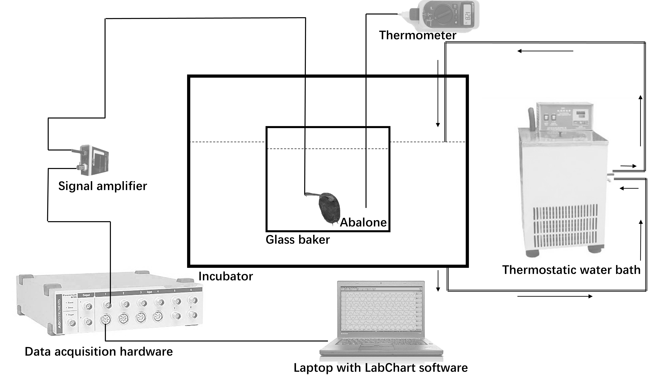

**Figure 1**

**Figure 2**

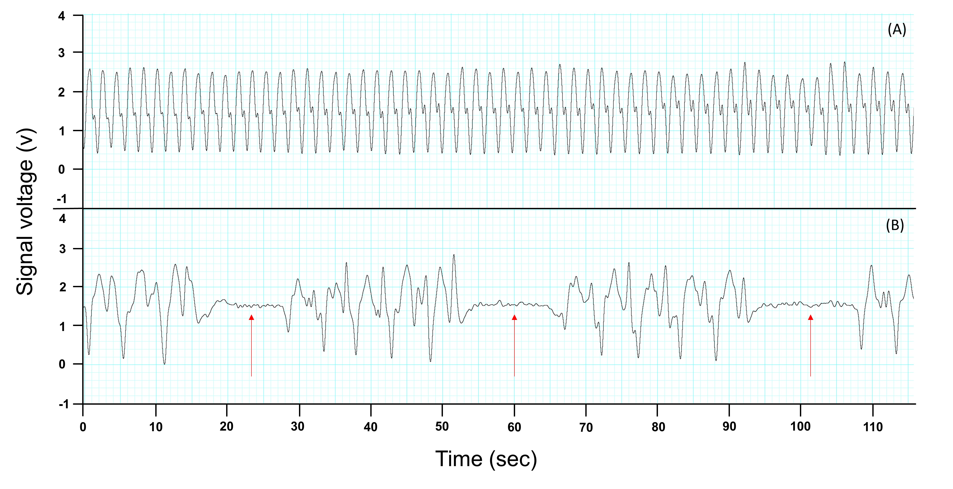

**Figure 3**

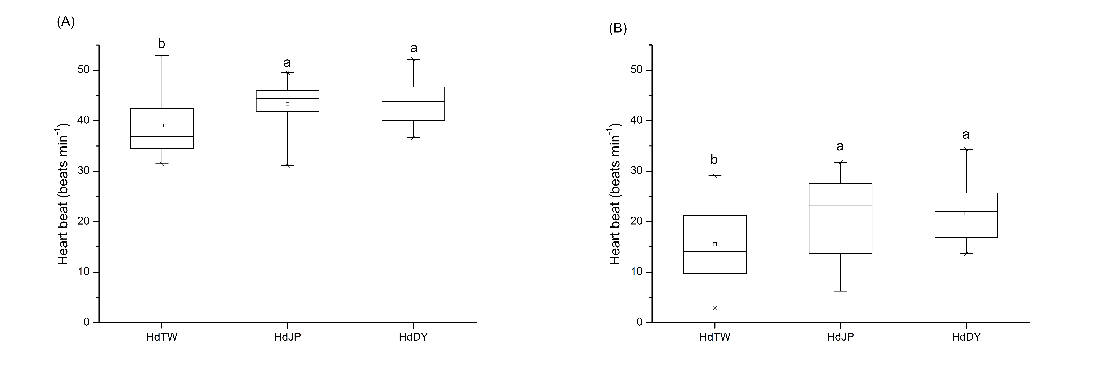

**Figure 4**



**Figure 5**

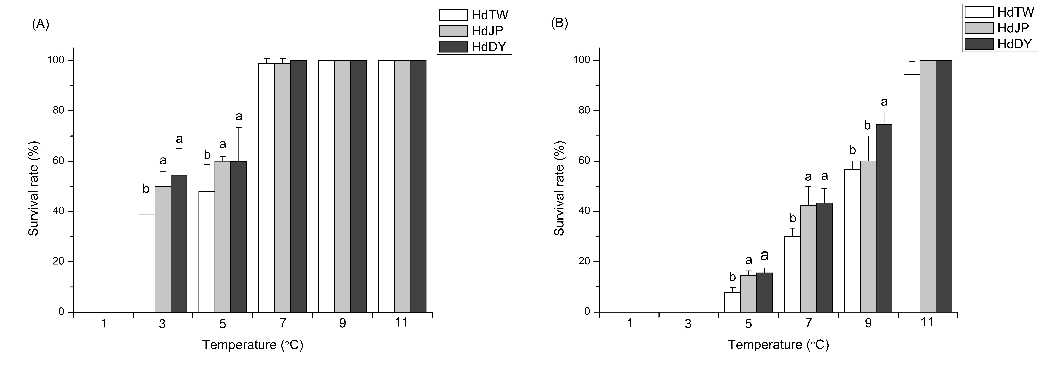

**Figure 6**

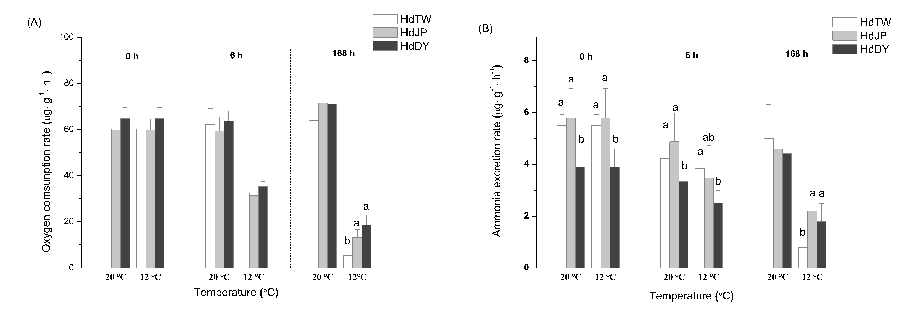

**Figure 7**